Parkview Elementary School

**Learner Résumé**

# Strengths and Challenges

Street:

City/State:

Zip:

Phone: (920)

### **My Goal for 3rd Grade**

## **Ways I Help**

Family Members:

Name:

Word Smart

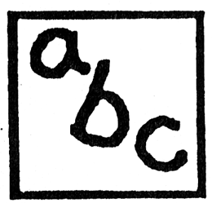

Number Smart

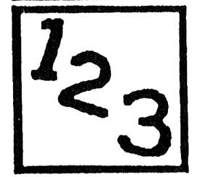

People Smart



Music Smart



Self Smart



Visual Smart



Nature Smart



Body Smart



My Multiple

Intelligences



My Learning Style

Auditory / Visual / Kinesthetic

MC900048085[1]

**My Proudest Accomplishments**

**My Character Traits**

Subjects I Like

#### When I Grow Up

**Books I Like:**

Interests